The Data Management Landscape: Microsoft SQL Server 10 Years Later
Microsoft® SQL Server™
Published: November 2002
A look back over the past 10 years of Microsoft SQL Server on Windows

Executive Summary
Over the past 10 years, Microsoft SQL Server has helped shape a new data management landscape. With innovative features such as self-optimizing and enterprise-class reliability and scalability, Microsoft SQL Server has come a long way from its beginnings on Microsoft Windows NT in the fall of 1993. According to industry reports, SQL Server today has achieved forty percent (40%) market share on the Windows platform. Also, over the years, SQL Server has had double-digit growth every year on average on the Windows platform. Much of this growth can be attributed to the innovative features introduced in SQL Server and also to the low total cost of ownership (TCO) and cost savings that customers gain through adopting SQL Server as their data management platform. Finally, SQL Server has evolved to become a leader in the Business Intelligence space with its integrated analysis services and data mining technologies. Read through some of the interesting facts contained in this document to see how Microsoft SQL Server has become a leader in the data management and Business Intelligence spaces.

The Changing Landscape in Data Management

Database Market Share
Over the past 10 years, SQL Server has experienced tremendous growth due to two primary factors: continual introductions of new and innovative database features and continued TCO savings enjoyed by SQL Server customers. This has made SQL Server the most popular database on the Windows platform. For the year 2001, market studies show that SQL Server leads all other vendors on Windows with forty percent (40%) share. The graphics below illustrate the current landscape of the database market.

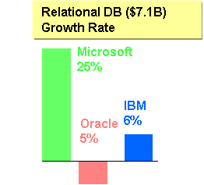
Figure 1: In the overall relational database market, SQL Server has grown twenty-five percent (25%) over the past year. Meanwhile, the competition has declined over this same period. Much of this growth can be attributed to the innovations that SQL Server has introduced to the data management industry. To learn more about the innovations of SQL Server, please read the 10 Firsts of SQL Server whitepaper.

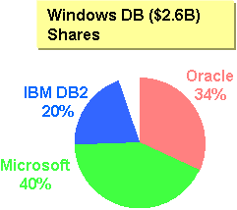
Figure 2: In the overall Windows database segment, SQL Server is the most popular database with forty percent (40%) market share. Customers such as Pennzoil, CompUSA, and Countrywide are some of the customers who have benefited from SQL Server and are helping Microsoft shape the future of SQL Server.

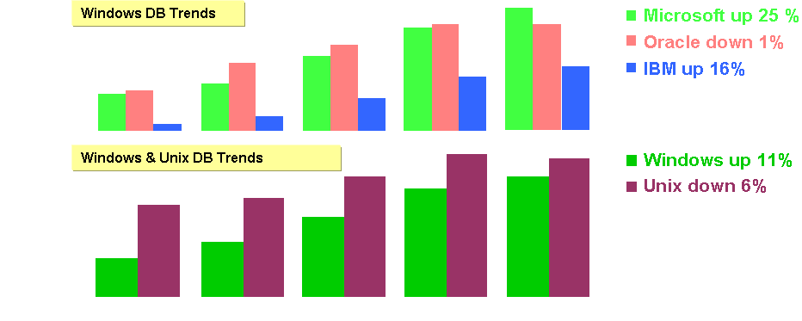

Figure 3: Over the years, Microsoft SQL Server has led the Windows database market in overall growth rates. SQL Server has grown steadily in this segment since 1997 and has taken the lead from its competition in terms of overall market share. Also, Windows has also gained steadily on Unix platforms as the operating system that customers run their data management solutions on.

ISV Application Market Share
Microsoft SQL Server has seen tremendous growth in the number of customers deploying ISV applications such as Customer Relationship Management (CRM), Enterprise Resource Planning (ERP), and Supply Chain Management (SCM) on the SQL Server platform. Many of these ISVs applications are the lifeblood of a corporation because they provide mission-critical functionality and information for the corporation to make better decisions, faster. SQL Server provides the enterprise-class database that helps corporations running these applications to achieve high availability and reliability of their data. The following graphic shows the breakdown of database usage in customers for ISV applications.

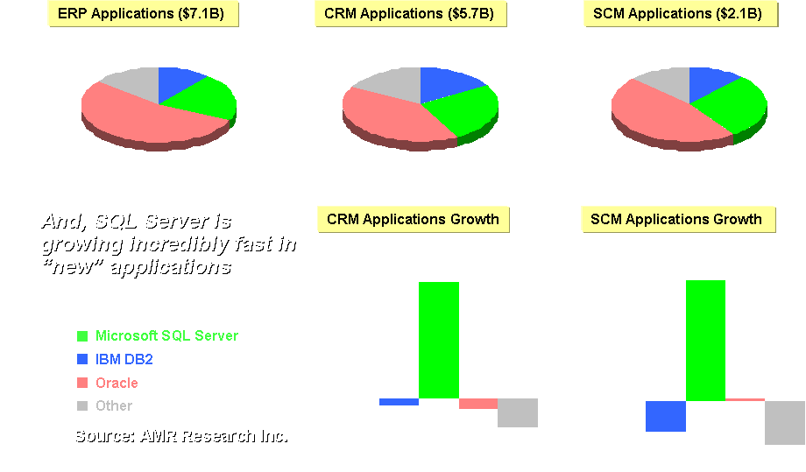Figure 4: According to AMR Research, SQL Server is growing faster than the competition as the database platform for ISV applications. In the CRM and SCM space, SQL Server is seeing 100% or greater growth as the database for these types of applications. Customers are adopting SQL Server because of its self-managing and self-optimizing capabilities which allow ISV applications to run faster. Customers deploying ISV applications on SQL Server also save money due to the lower operating cost of SQL Server. To learn more about the cost savings of SQL Server, read a recent whitepaper that outlines the total cost of ownership savings gained by customers running SQL Server for their ERP applications.

SQL Server: Leader in Business Intelligence
By listening to feedback from our customers, Microsoft helped shape the Business Intelligence industry by providing integrated OLAP capabilities into the Microsoft SQL Server database platform. Customers wanted this level of integration between their relational and Business Intelligence platforms since this integration leads to lower IT costs and increased productivity for information workers. Microsoft SQL Server, today, provides this level of integration through its integrated Microsoft SQL Server Analysis Services platform. In addition, SQL Server has also integrated comprehensive data mining capabilities directly into SQL Server so that customers can get more knowledge out of their information, whether that information is stored in relational or OLAP format. Finally, the SQL Server Business Intelligence solution integrates with the productivity tools that customers use today such as Microsoft Office, so information workers can use their existing tools but get the information analysis horsepower they need from a robust, reliable backend system such as SQL Server.

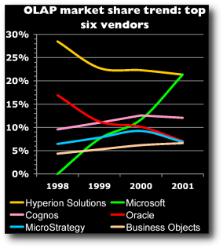
Figure 5: The graphic above shows market share statistics from the OLAP Report. After first introducing Business Intelligence capabilities in 1998 with SQL Server 7.0, Microsoft tied for the leadership position in 2001 and shows strong growth in the Business Intelligence market over the past three years. With the innovative Business Intelligence features in SQL Server 2000, customers can depend on SQL Server to help them turn data into knowledge and help their information workers be more productive everyday.

Strong Partner Ecosystem
SQL Server has also seen tremendous growth in the partner community over the past ten years. Over 2,000 partners build solutions on SQL Server today. And this partner ecosystem continues to grow daily. Below are some SQL Server partner and industry analyst testimonials about SQL Server:

“It may seem strange that I would pick a relational database platform as my favorite technology. To most people, the database is viewed as an essential, but not very exciting, piece of technology. Having been a user since version 4.2, I have seen Microsoft SQL Server evolve from a basic database with a limited set of tools to an enterprise-capable database platform with tools to spare. I still remember the day I used SQL Server 7.0 for the first time and was quite impressed with tools like Data Transformation Services, Query Analyzer and Profiler.

“Now SQL Server comes in a number of flavors to support multiple environments, ranging from the desktop to the enterprise to even the PDA. In the past year, I had the opportunity to work with SQL Server CE in conjunction with SQL Server 2000. That technology proved to be the essential link between the field and the main office, just another example of how SQL Server has evolved.”

-Eric Raarup, director of business solutions, Inetium
Reprinted from VARBusiness (http://crn.channelsupersearch.com/news/var/38321.asp)

"The fact that the Microsoft platform requires so little management and administration enables companies to stay focused on the benefits that Radix provides. While there is still a layer of database management, the overall involvement is minimal compared with other products competing in this space -- and that's highly advantageous for customers that want to stay focused on serving their customers, bringing new products online and taking advantage of rapidly emerging market opportunities. By deploying Radix IDC on an entirely Microsoft-based platform, RiverRock provides a solution that is as much as 10 times less expensive than its Oracle/Sun counterpart -- and that provides significant downstream management and scaling cost efficiencies."
- Cody Hill, vice president of product marketing at RiverRock Systems

"SQL Server 2000 was the only database that met all our requirements, and its prebuilt functionality contributed to our ability to get to market in half the time it would have taken on any other platform. Selecting a database is a long-term decision, and I'm confident that SQL Server 2000 will meet every one of our needs moving forward."

- Frank LaQuinta, CTO for i-Deal

"SQL Server has evolved from a standalone product to a central piece in almost everything Microsoft is doing on servers. That says a lot about what the team has accomplished: Microsoft itself is willing to bet its future in markets like e-commerce, messaging, and business applications on SQL Server."

-B. Robert Helm, Director of Research, Directions on Microsoft, an independent research firm focused exclusively on Microsoft strategy and technology

Read about the Gartner Group’s view on Microsoft SQL Server 2000 on the Gartner website at http://www4.gartner.com/DisplayDocument?id=354173

Microsoft Certified Database Administrators (MCDBA)
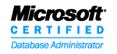
Another indicator of the growth and maturity of SQL Server is the growing number of partners and customers who are certified on SQL Server. The Microsoft Certified Database Administrator certification (MCDBA), which was first introduced in 1998, now has over 85,000 certified professionals on SQL Server. Part of this growth over the years is attributed to the growing popularity of SQL Server as a mission-critical, enterprise capable database and Business Intelligence system over the past 10 years. To learn more about the MCDBA certification, please visit http://www.microsoft.com/mcdba/.

Strong Customer Adoption
Many of the partners and MCDBAs discussed above have helped customers deploy, manage, and develop on SQL Server over the past 10 years. There are many reasons that customers are quickly adopting SQL Server including the manageability, reliability, and productivity features of SQL Server. The list of reasons goes on, but rather than provide just a list of innovative features, customer words are the best validation of why customers trust their businesses on SQL Server:

“For price-performance, Microsoft beats the competition hands down. As for manageability and uptime, I can say that anybody who says Windows 2000 and SQL Server 2000 aren't ready for prime time hasn't honestly looked at the Microsoft platform in the last year.”

- Patrick Parker, Director of Data Systems, MarketWatch.com, Inc.

“We’ve survived a tremendous increase in growth over the last two years with hardly any hiccup at all. We have met all of our goals for uptime. For all intents and purposes, all the production SQL Servers are running non-stop. The service has been seamless on the clustered production environment. The failover we have experienced is actually to bring down a node for scheduled maintenance.

Right now the production environment is made out of several hundred SQL Servers and several Terabytes of active production data running on it. It’s growing probably at the rate of 40% a year. I think it is a testament to Microsoft SQL Server 2000 and Microsoft clustering technology that we are able to handle any increases that come up.”

- Bob Lirag, Vice President of Client Server Services, Countrywide Home Loans

“The Microsoft platform allowed us to do something that I consider amazing. We were able to build a very sophisticated application in less than 18 months with just three developers. SQL Server 2000 gives us a robust and scalable data warehouse that is completely integrated with the Analysis Services and Comshare Decision that we used to create and present the business intelligence. Had we not been working with the Microsoft platform, I think our team would have required an additional developer -- and a very experienced one costing perhaps $100,000 a year in salary plus fully loaded benefits. And this position couldn't just go away when the product was launched. So, for our project, we can see real savings because of the easier development that comes from the tightly integrated Microsoft platform."

- Tom Ryan, chief technology officer of FutureWork Systems

"Over the last year, my thinking has turned around 180 degrees. Not only does our new Microsoft-based solution give us the scalability we need more cost-effectively than Solaris, but it provides a much greater level of agility in bringing new functionality to market and responding to rapidly changing business needs. It was clearly instrumental in getting our straight-through processing solution completed on time and within budget."

- Michael Blomfield, deputy general manager for Commonwealth Securities, LTD.

The Next 10 Years of SQL Server
Microsoft is working with partners and customers to help shape the future direction of SQL Server. By working closely with our partners and customers, Microsoft is ensuring that the future of SQL Server meets the most demanding needs of the diverse community that has adopted SQL Server over the years. Microsoft is committed to helping our partners and customers become more productive while at the same time providing a scalable, reliable, secure, and dependable data management solution that delivers the best economics in the industry. By investing in SQL Server today customers and partners can start taking advantage of the innovations, cost savings, and productivity enhancements that SQL Server provides. The next release of SQL Server, codenamed Yukon, will revolutionize the industry just as previous SQL Server editions have over the past 10 years. Yukon will provide new manageability, developer productivity and Business Intelligence enhancements that will help customers get even more cost savings and productivity out of their SQL Server investments. Yukon will also deliver further advancements in security, scalability, and availability.

If you are not a SQL Server customer today, now is the time to learn about SQL Server. If you are a SQL Server customer, your investment in SQL Server will be enhanced over the next 10 years with innovative features that will drive new gains in productivity across your organization, and enable you to deploy highly scalable operational and Business Intelligence solutions while streamlining and simplifying the management of those systems.

Whether you are or are not a SQL Server customer today, we hope you will learn more about SQL Server, its innovations, and the customers entrusting their business to SQL Server today, by visiting the SQL Server website at http://www.microsoft.com/sql/.

 2002 Microsoft Corporation. All rights reserved.

Microsoft, Microsoft Office, Microsoft SQL Server, Microsoft SQL Server Analysis Services, and Microsoft Windows are either registered trademarks or trademarks of Microsoft Corporation in the United States and/or other countries.

The names of actual companies and products mentioned herein may be the trademarks of their respective owners.

